**Artificial Intelligence**

Introduction

The Science and Engineering of making intelligent Machines, especially intelligent Computer programs. -John McCarthy. Artificial Intelligence is an approach to make a computer, a robot, or a product to think how smart human think. AI is a study of how human brain think, learn, decide and work, when it tries to solve problems. And finally this study outputs intelligent software systems. The aim of AI is to improve computer functions which are related to human knowledge, for example, reasoning, learning, and problem-solving.

The intelligence is intangible. It is composed of

Reasoning

Learning

Problem Solving

Perception

Linguistic Intelligence

The objectives of AI research are reasoning, knowledge representation, planning, learning, natural language processing, realization, and ability to move and manipulate objects. There are long-term goals in the general intelligence sector.

Approaches include statistical methods, computational intelligence, and traditional coding AI. During the AI research related to search and mathematical optimization, artificial neural networks and methods based on statistics, probability, and economics, we use many tools. Computer science attracts AI in the field of science, mathematics, psychology, linguistics, philosophy and so on.

**Applications of AI**

Gaming − AI plays important role for machine to think of large number of possible positions based on deep knowledge in strategic games. For example, chess, river crossing, N-queens problems etc.

Natural Language Processing − Interact with the computer that understands natural language spoken by humans.

Expert Systems − Machine or software provide explanation and advice to the users.

Vision Systems − Systems understand, explain, and describe visual input on the computer.

Speech Recognition − There are some AI based speech recognition systems have ability to hear and express as sentences and understand their meanings while a person talks to it. For example Siri and Google assistant.

Handwriting Recognition −The handwriting recognition software reads the text written on paper and recognize the shapes of the letters and convert it into editable text.

Intelligent Robots − Robots are able to perform the instructions given by a human.

**Major Goals**

* Knowledge reasoning
* Planning
* Machine Learning
* Natural Language Processing
* Computer Vision
* Robotics

1. **Write a python program to implement simple Chatbot?**

**Code:**

print("Simple Question and Answering Program")

print("=====================================")

print(" You may ask any one of these questions")

print("Hi")

print("How are you?")

print("Are you working?")

print("What is your name?")

print("what did you do yesterday?")

print("Quit")

while True:

question = input("Enter one question from above list:")

question = question.lower()

if question in ['hi']:

print("Hello")

elif question in ['how are you?','how do you do?']:

print("I am fine")

elif question in ['are you working?','are you doing any job?']:

print("yes. I'am working in KLU")

elif question in ['what is your name?']:

print("My name is Emilia")

name=input("Enter your name?")

print("Nice name and Nice meeting you",name)

elif question in ['what did you do yesterday?']:

print("I saw Bahubali 5 times")

elif question in ['quit']:

break

else:

print("I don't understand what you said")

**Output:**

Simple Question and Answering Program

==============================

You may ask any one of these questions

Hi

How are you?

Are you working?

What is your name?

what did you do yesterday?

Quit

Enter one question from above list:hi

Hello

Enter one question from above list:how are you?

I am fine

Enter one question from above list:are you working?

yes. I'am working in KLU

Enter one question from above list:what is your name?

My name is Emilia

Enter your name?sachin

Nice name and Nice meeting you sachin

Enter one question from above list:quit

**Write a python program to implement Water Jug Problem?**

A Water Jug Problem: You are given two jugs, a 4-gallon one and a 3-gallon one, a pump which has unlimited water which you can use to fill the jug, and the ground on which water may be poured. Neither jug has any measuring markings on it. How can you get exactly 2 gallons of water in the 4-gallon jug?

Let X represent the content of the water in 4-gallon jug.

Let Y represent the content of the water in 3-gallon jug.

Write a program in python to define a set of operators (Rules) that will take us from one state to another:

Start from initial state (X=0, Y=0)

Reach any of the Goal states

(X=2, Y=0)

(X=2, Y=3)

Find the minimum number of steps to reach any the above mentioned goal states.

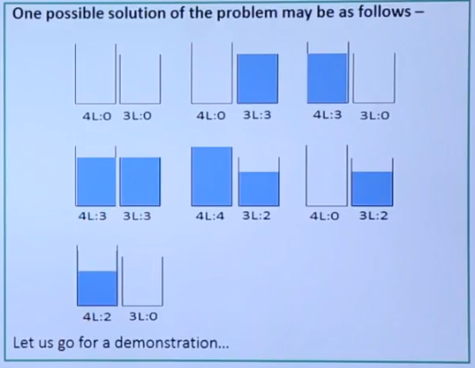

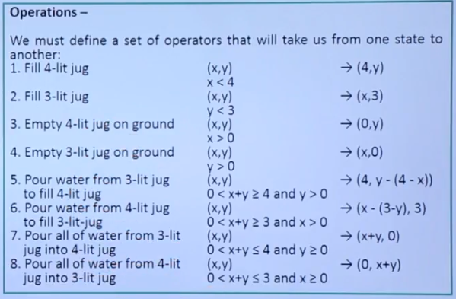

**Code:**

print("Water Jug Problem")

x=int(input("Enter X:"))

y=int(input("Enter Y:"))

while True:

rno=int(input("Enter the Rule No"))

if rno==1:

if x<4:

x=4

if rno==2:

if y<3:

y=3

if rno==3:

if x>0:

x=0

if rno==4:

if y>0:

y=0

if rno==5:

if x+y>= 4 and y>0:

y=y-(4-x)

x=4

if rno==6:

if x+y>=3 and x>0:

x=x-(3-y)

y=3

if rno==7:

if x+y<=4 and y>0:

x=x+y

y=0

if rno==8:

if x+y<=3 and x>0:

y=x+y

x=0

print("X =" ,x)

print("Y =" ,y)

if (x==2):

print(" The result is a Goal state")

break

**Output:**

Water Jug Problem

Enter X:0

Enter Y:0

Enter the Rule No2

X = 0

Y = 3

Enter the Rule No7

X = 3

Y = 0

Enter the Rule No2

X = 3

Y = 3

Enter the Rule No5

X = 4

Y = 2

Enter the Rule No3

X = 0

Y = 2

Enter the Rule No7

X = 2

Y = 0

The result is a Goal state